Spread Sheet – Spent Money 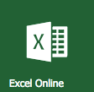

Instructions Marks
Student lists at least 10 items, (one in each category). | /1
The total cost added up is using the SUM function. | /2
Contains a chart | /2
Uses a formula to calculate Canadian dollars based on current exchange rate | /2
Grand Totals use formulas to sum the cost in RMB and to sum the cost in CAD | /2
Spreadsheet includes all required columns with accurate information | /1
Student spends time on appearance and formatting | /1
Two tables | /2
Total | /13

In January, I (Miss Fraser) went on a trip. I have kept a list of all the money I spent on my trip. You will need to organize and calculate my total spending in both RMB and Canadian Dollars. The categories are Transportation, Entertainment, Food, Shopping, and Accommodation. You also need to show the total for each category.
Create an excel spreadsheet to list all of the things you spent money on. It must include the following cells:
Row 1: TITLE Row 2: YOUR NAME Row 3: Item Name, Category, Cost, Quantity, Final Cost, Final Cost (CAD)
Row 4-13 should be the items (*there are more than 10 listed, you need to include at least 10*)
Final Row: Grand total
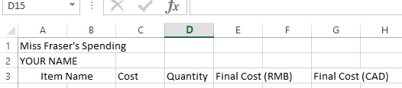

You must use formulas to calculate the following things:
- Final Cost = Quantity * Cost
- Final Cost (CAD)= Final Cost * 0.22
- Grand Total = SUM (Final Cost from rows 4-14)
- Table 2 with the categories and SUM.
- Make a chart from the information in Table 2 **Your chart should be a pie chart**

Expenses of my vacation
Item | Cost in RMB | Quantity | Category
Flight to Thailand | 1250 | 1
Taxi from Airport | 175 | 1
Hotel | 400 | 10
Dinner | 65 | 7
Magnets | 20 | 3
Dress | 120 | 2
Scuba diving | 700 | 1
Theme Park | 500 | 1
Painting | 200 | 1
Lunch | 100 | 7
Taxi to Airport | 185 | 1
Flight to Wuhan | 1700 | 1

You will need to create two (2) different tables. One showing the grand total spent for the entire trip, and one showing the SUM or grand total for each category.
